Pilotage Classes

Plan how to take your boat on the Summer Cruises
The intention of these classes is to build on the Navigation classes delivered in previous years by Colin Stracey of Premier Sailing. The focus will be on producing passage plans you can use for your boat. We will work together with help on hand to ‘look over your shoulder’, offer coaching and answer your questions.
What we’ll do:
- Flesh out the details of the cruise itineraries
- Discuss the reasons behind the itineraries
- Consider weather variations / secondary ports
- Prepare passage plans for each yacht
- Identify vital destination info
- Q&A at the end of each class
When:
- Four Tuesday evenings commencing 12 March (subsequent dates subject to demand}
- Arrive, set up and grab a coffee 19.30
- Finishes 21.00. Q&A until 21.15, bar open, leave and lock up by 22.00
What you need to bring:
- Imray C 1 chart (Thames Estuary); essential for this class (charts can be Admiralty equivalent)
- Imray Y17 chart (Rivers Colne, Blackwater and Crouch): best chart for the Blackwater
- Imray Y16 chart (Walton to Ipswich and Woodbridge); not essential - but very useful
- East Coast Pilot Book (doesn’t have to be up to date)
- Portland / Breton Plotter
- Dividers
- Pen, paper, pencils including a 2B pencil for chart work
Summer Cruise 29 June – 6 July 2024
We are adding an optional week onto the Osea Island weekend (29&30 June) for the 2024 Summer Cruise. Destination East Coast returning Saturday 6 July. Given favourable conditions, from Osea the itinerary is as follows:
30 June depart Osea 08.00 destination Walton/Titchmarsh 2 nights.
2 July depart Titchmarsh 11.00 destination Ipswich (16 miles), 2 nights.
4 July depart Ipswich 11.30 destination Suffolk Yacht Harbour (Levington). 1 night.
5 July depart SYH 05.00 destination Burnham Marina (30 miles – HW 13.00), 1 night.
6 July depart Burnham 11.00 destination URYC (arrive before HW 14.48).

Alternative Summer Cruise itinerary if adverse weather conditions (e.g. forecast for strong NE winds):
30 June depart Osea 06.00 destination Heybridge Basin (4 miles) 07.00 stay 2 nights.
2 July depart Heybridge 10.00 destination West Mersea (11 miles) 1 night.
3 July depart W Mersea 11.00 destination Brightlingsea (7.5 miles) 2 nights.
4 July excursion - take 2 or 3 larger yachts up the River Colne to Wivenhoe (5 miles) depart 08.00 with as many members who want to go, arrive by 10.00 on Colne SC hammerhead, depart 1 hour after HW circa 13.30, return to Brightlingsea berth by 15.30 at latest.
5 July depart Brightlingsea 08.30 destination Burnham Marina via Raysand Channel (18 miles) arrive 13.00 -14.00
6 July depart Burnham 11.00 destination URYC (arrive before HW 14.48)
Useful link:
Harwich Harbour tide time table: TT individual pages 2024.indd (hha.co.uk)

Class one

Osea Island weekend
Three step process:
- Tides “Always work your tides”
Remember most small sailing yachts will achieve an average sailing speed of 4 knots through the water. In contrast, a typical modern 10 metre yacht will average 5, yes it may achieve 7 knots in perfect sailing conditions, but equally, when the wind falls light, the speed may be half that.
The smaller the boat, the greater the influence of the tide over the distance you plan to travel.
1a. Tide times: Osea Island weekend
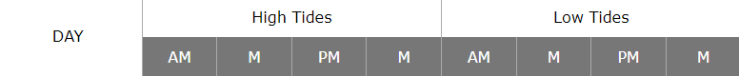
June 2024
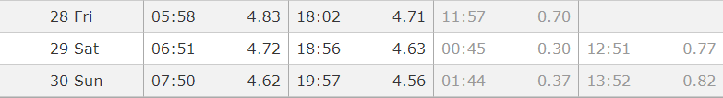
1b. Tidal differences: know the tide times where you are sailing, check the tidal constants.
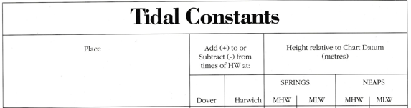
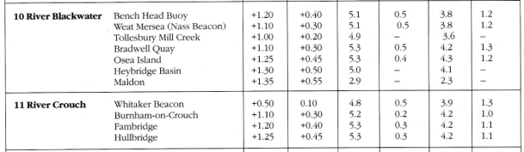
HW at Hullbridge is 15 minutes after Burnham (average) and 35 mins after Whitaker (Swin Spitway)
1c. Make a note of your ‘tidal gates’. These are the points on your route you should arrive at to make best use of the tide. For example, sailing to Osea, plan to be at the Swin Spitway by low water at the latest as you don’t want to be sailing against the flood tide. You want the flood tide to start running in your favour once you have turned to port at the Wallet Spitway buoy, so time it so it helps you to make your way toward the Blackwater.
Its worth remembering that 30 minutes either side of low water, andr high water, the tide is mostly slack, so you have flexibility in terms of achieving your tidal gates.
1d. Yacht Cruising is not just sailing. More accurately, it should be described as passage making. For example, you calculate the distance you must cover before the tide turns against you. You know your boat can sail at 4 knots with a favourable breeze, plus you have at least I knot of tide in your favour (probably more like 1.5 knots if a spring tide). This means your boat will easily achieve 5 knots over the ground.
However, if on the day the wind is dead on the nose, you will have to tack. This will effectively reduce your speed over the ground (SOG) in that direction to 2 knots, plus a knot from the tide = 3 knots. If you know this wind direction in advance from the weather forecast, you should recalculate at 3 knots SOG and, assuming its possible, leave earlier to have enough time to cover that part of the trip during which the wind is against you.
Equally you may set off with a favourable breeze and it fades away, if you then can’t achieve 5 knots over the ground, start your engine and apply just enough power to keep up your average speed to achieve your passage plan.
1e. A final word on tides. Wind over tide conditions can be surprisingly boisterous. For example, a strong spring tide pushing against a fresh westerly breeze can turn the entrance of the Blackwater into a rough spray drench beat. In this case a strong tide under your boat is only making things worse. Consider if you would make better and far easier progress by timing arriving at the most exposed part of the trip at slack water. An alternative, with a rising tide, is to head into shallower water on the port side of the river and skirt the sand banks in about 2 to 3 meters of water.
This way you reduce the fetch of the waves (the distance over which the wind can build up the waves) plus the strength of the tide is massively reduced in the shallows. You might need to furl your genoa, harden in the mainsail and just motor, keeping a keen eye on your echo sounder. Crucially this would enable you to make progress in relatively smooth water. Much easier compared to the conditions further out where the tide is running hard. This is passage making. It can also be good seamanship, especially if you don’t have a strong crew.
The idea is to arrive safely at your destination and not turn a sailing trip into a battle against the elements.
Every passage plan should be flexible enough to handle a variety of conditions.

- Weather Forecast and outlook.
Consider the likely impact on your passage plan, this includes the decision not to go.
Postponing a trip to the next day may transform the ability of your boat to get there as well as comfort of the crew. If the prevailing conditions are unsettled agree a ‘go or no go’ day and time. Check the forecast then and weigh up the ability to achieve your passage plan.
Know your weather app: Windguru
Blues and greens, it will be serene,
Orange and yellow, great on the beam and downwind just follow,
Wind on the nose and gusting red? Unless river sailing… stay in bed.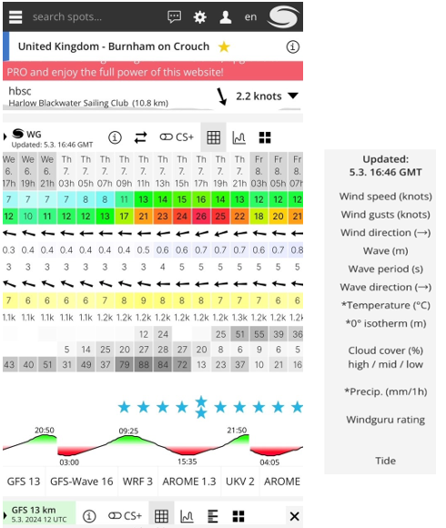

- Plot your course. Prepare a passage plan. Once you commence your trip use your plotter, but always check off your progress using your paper chart. It’s imperative to know where you are in relation to your chart. It is also particularly useful to measure and check actual progress against your passage plan and adjust as you go. Then you’ll know what to expect and when.
Appendix 1 – print and keep in the back of your Pilot Book
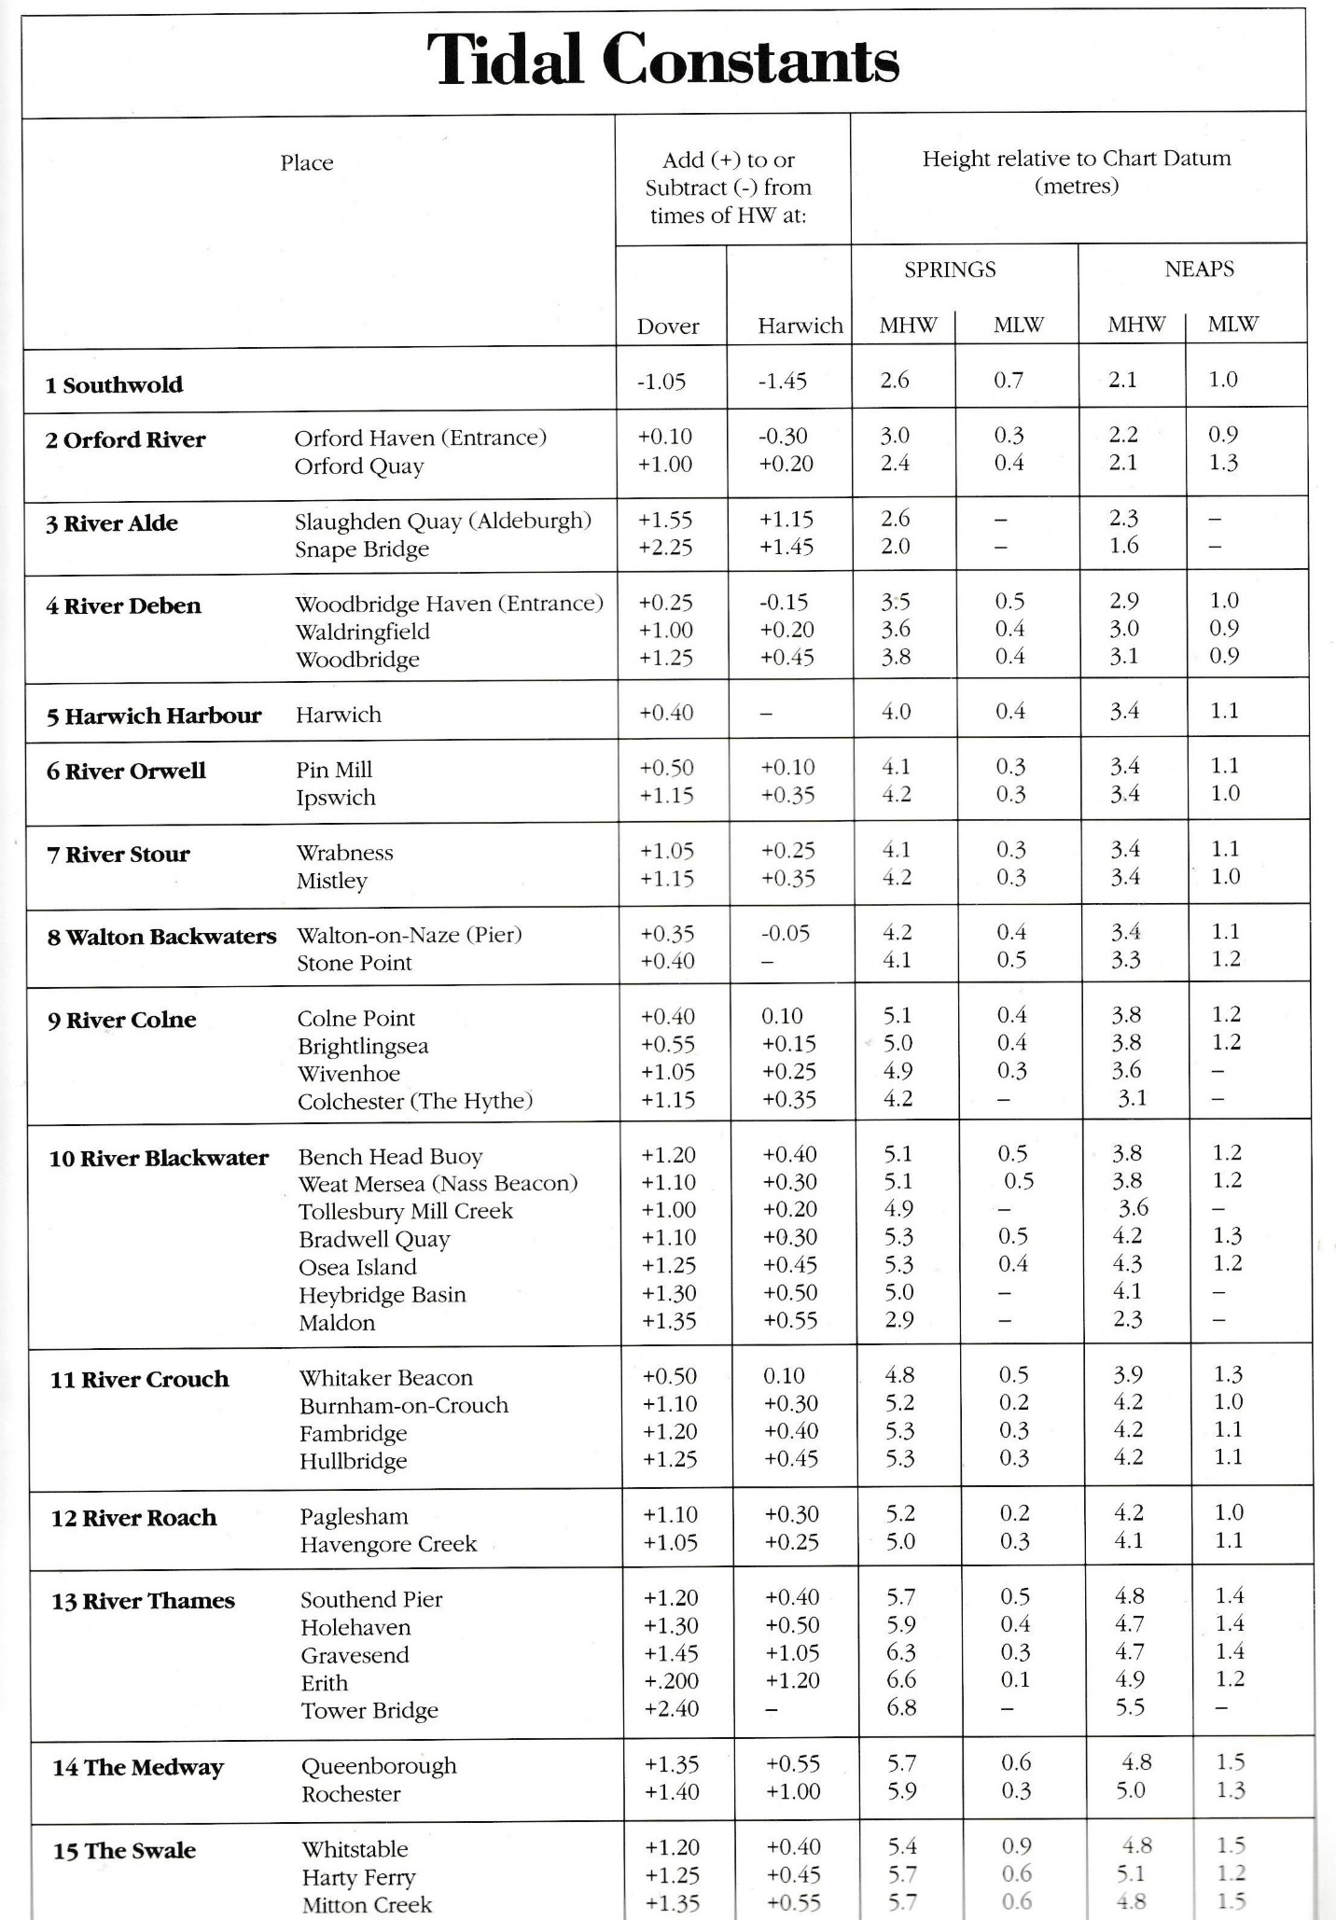
Passage Plan to Medway 2023
Appendix 2: passage plan example of list layout
Course to steer
1 | Roach anchorage to Inner Crouch  Inner Crouch to Buxey No2 | 3 miles  3.75 m | 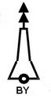 | 59
2 | Buxey No2 to Buxey No1 | 0.66 m | 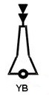 | 82
3 | From Buxey No2 follow buoyed channel for 2 miles at 64 degrees  Then 75 degrees to Inner Whitaker  (4 Hours tacking, or 2hrs favourable)  LOW WATER Whitaker circa 10.35 | 4.5m  Cover  12m by LW |  | 64  75
4 | Inner Whitaker to Maplin Approach  During Spring tides: This course may take you into shallow water, watch sounder, if necessary head to port until water deepens to resume course to Maplin Approach | 1.4m |  | 153
5 | Maplin Approach to East Maplin | 1.25m | 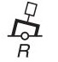 | 202
6 | East Maplin to Maplin Middle | 2.6m | 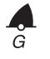 | 227
7 | Maplin Middle to Maplin Edge | 1.9m |  | 227
8 | Maplin Edge to Maplin | 2m |  | 218
9 | Maplin to Blacktail Spit | 3.6m |  | 231
10 | Blacktail Spit to South Shoebury | 3m |  | 249
11 | South Shoebury to Medway (buoyed channel) No1 | 2.3m |  | 211
12 | Medway No1 bouyed channel follow stb hand Green buoys - leaving wreck to Stbd. Stay just outside of buoyed channel and watch for regular commercial traffic (mainly coasters). | 4.5m  Cover 22.5 miles from Whitaker | Fort to stbd  Follow stbd hand buoys until past commercial quays | 249
ETA: 31.5 miles Whitaker to Upnor achievable by high water (HW Upnor 17.15hrs) with a favourable wind giving a min average 4 knots over the ground. Tide will turn foul by circa 17.00hrs by which time you should ensure past Sheerness and within the Medway. Springs = 6 knots SOG achievable.
Appendix 3
Passage Plan – example of rolling road layout
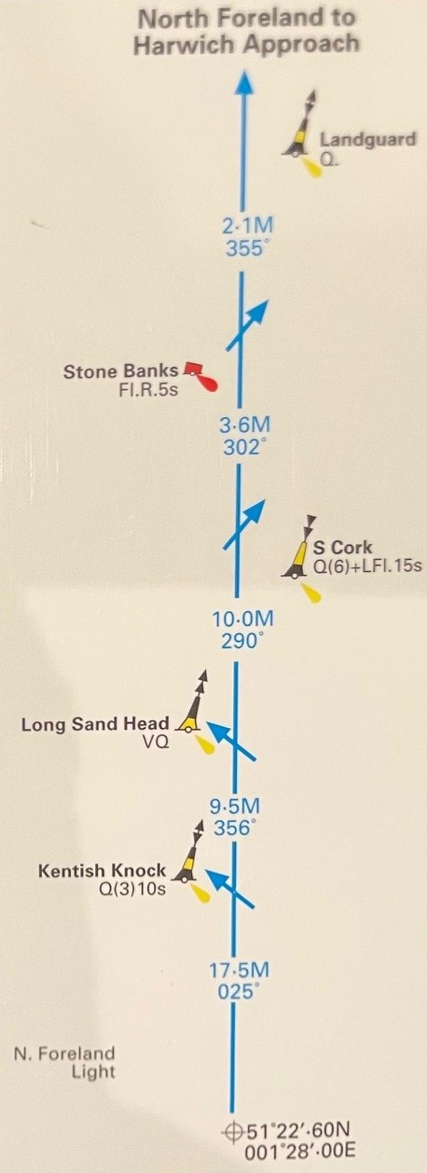

Appendix 4 - download and amend
Passage Plan to ……………Layout - example
Course to steer
1 | Description  EG Inner Crouch to Buxey No2 | Distance to next mark  3.75 m | Description or image of navigation mark | 59
2
3
4
5
6
7
8
9
10
11
12
Notes:

